**Project Design Phase-II Data**

**Flow Diagram & User Stories**

|  |  |
| --- | --- |
| Date | 18 October 2022 |
| Team ID | PNT2022TMID30922 |
| Project Name | VirtualEye - Life Guard For Swimming Pools To Detect Active Drowning |
| Maximum Marks | 4 Marks |

**Data Flow Diagram:**

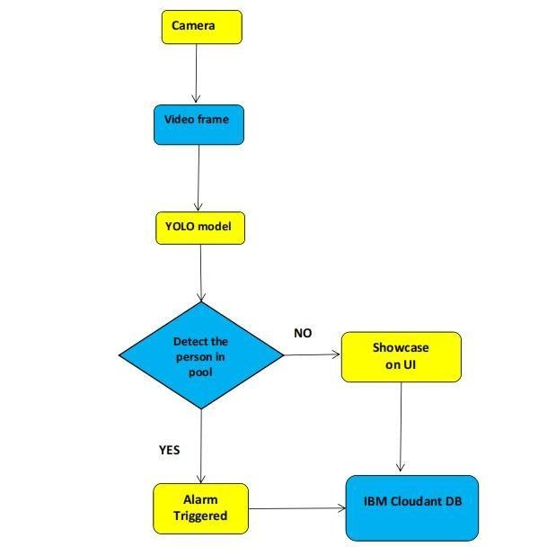

**User Stories**

Use the below template to list all the user stories for the product.

|  |  |  |  |  |  |  |
| --- | --- | --- | --- | --- | --- | --- |
| **User Type** | **Functional**  **Requirement**  **(Epic)** | **User Story**  **Number** | **User Story / Task** | **Acceptance criteria** | **Priority** | **Release** |
| Customer (Pool owner) | Installation | USN-1 | As a user, I can install the cameras and configure the system in swimming pools. | I can install the software and set up the cameras | High | Sprint-1 |
|  | Detection the drowning | USN-2 | As a user, I can monitor the swimmers by using cameras. | Camera surveillance | High | Sprint-1 |
|  | Notify  Lifeguard | USN-3 | As a user, I want to notify the lifeguard when drowning is detected. | I can set up the Alarm to alert the lifeguard | High | Sprint-2 |
| Customer  (Lifeguard) | Rescue people | USN-4 | As a user, I can save drowning people | I can save drowning people | High | Sprint-2 |
| Customer (Swimmer) | safety | USN-5 | I can swim without fear in the swimming pool | I can swim safely with the help of lifeguards | High | Sprint-3 |
| Customer Care Executive | Contact | USN-6 | User technical issue and help them to get resolved | I can contact customer care executive at any time | Medium | Sprint-4 |
| Administrator | Database | USN-7 | Database Management, Server  Management | I can access data without any delay | High | Sprint-2 |